CO5 – Assessment
Employee
Output:
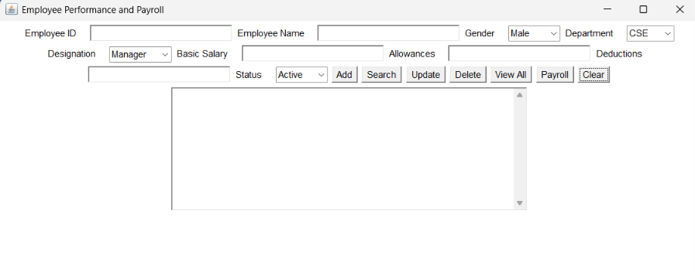
Add function:
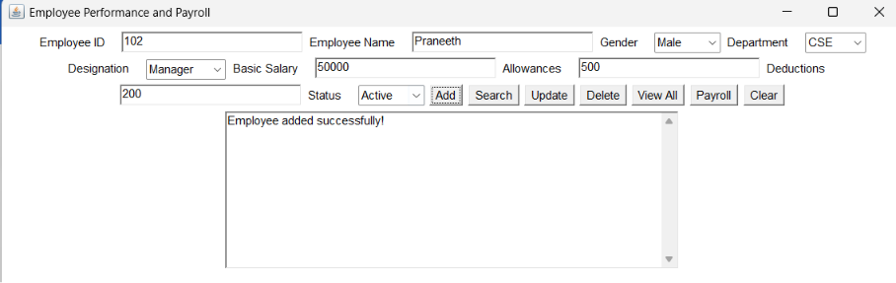
Search function:
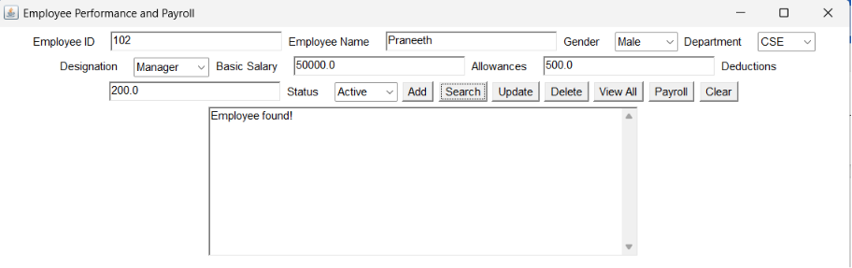
Update function:
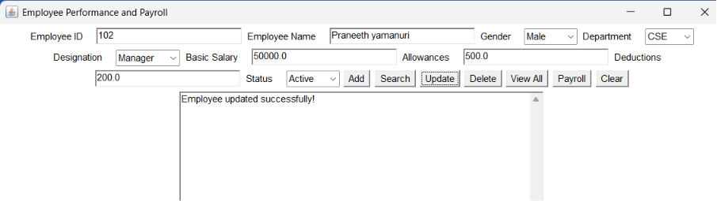
Delete Function:
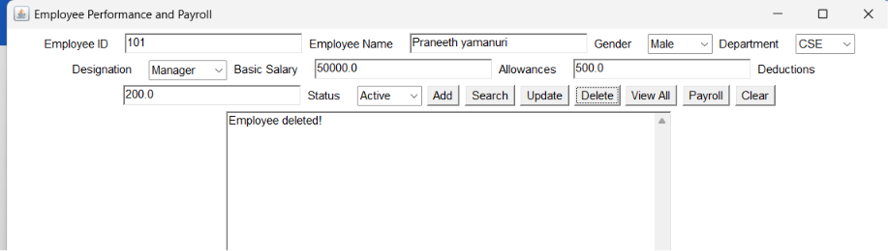
View All function:
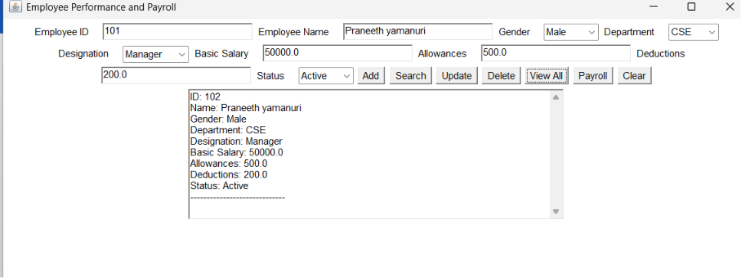

Payroll:
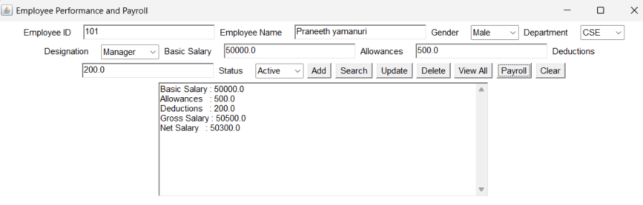
Clear:
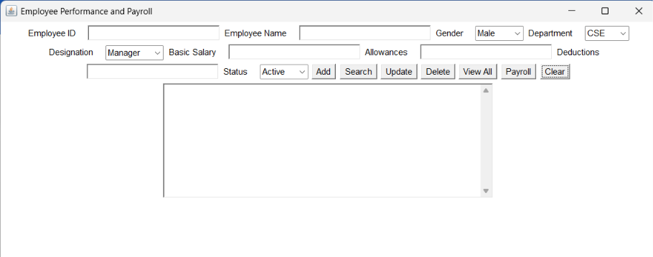
SQL database:
